Configuring HDFS High Availability for Name node and Secondary Name node using Cloudera Manager

Login to Cloudera Manager

- Login to Cloudera Manager using ip address and port 7180
Eg: http://3.235.181.239:7180/
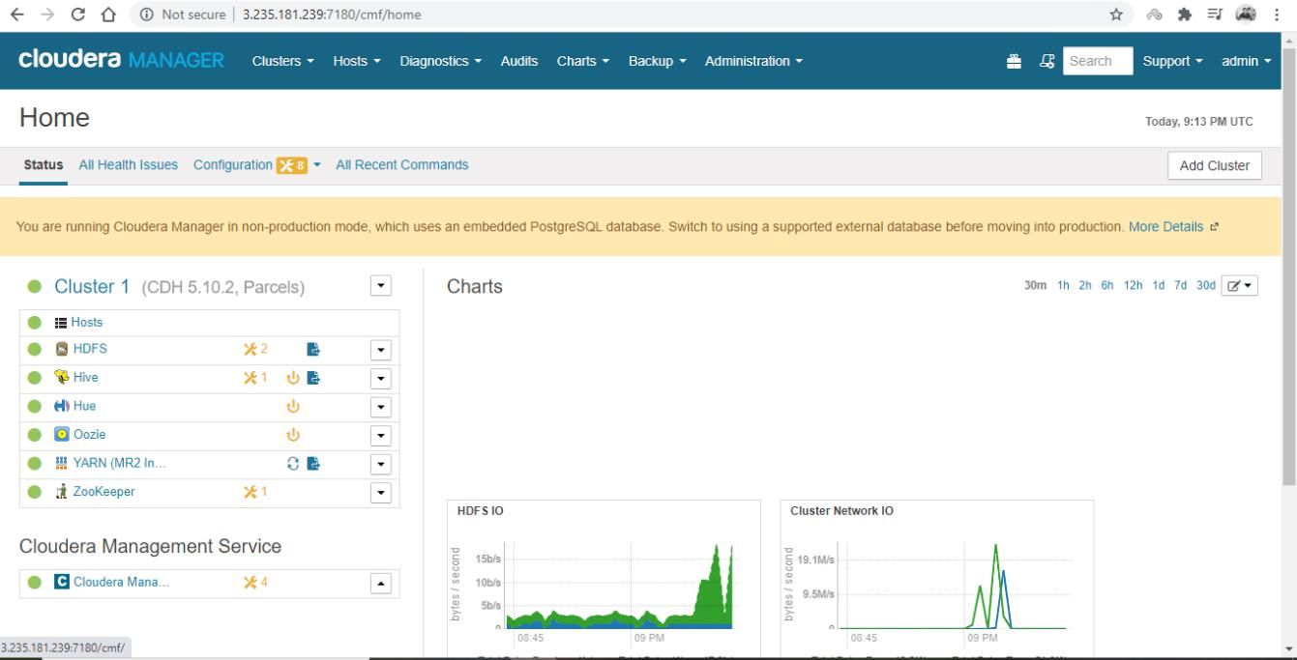

- In HDFS when you configure high availability there should be only one host acting as active and another host acting as standby.

- Now if you want to configure High availability for HDFS where name node acts as master and Secondary name node as standby.

- Go to HDFS Service → Actions → Enable High Availability.

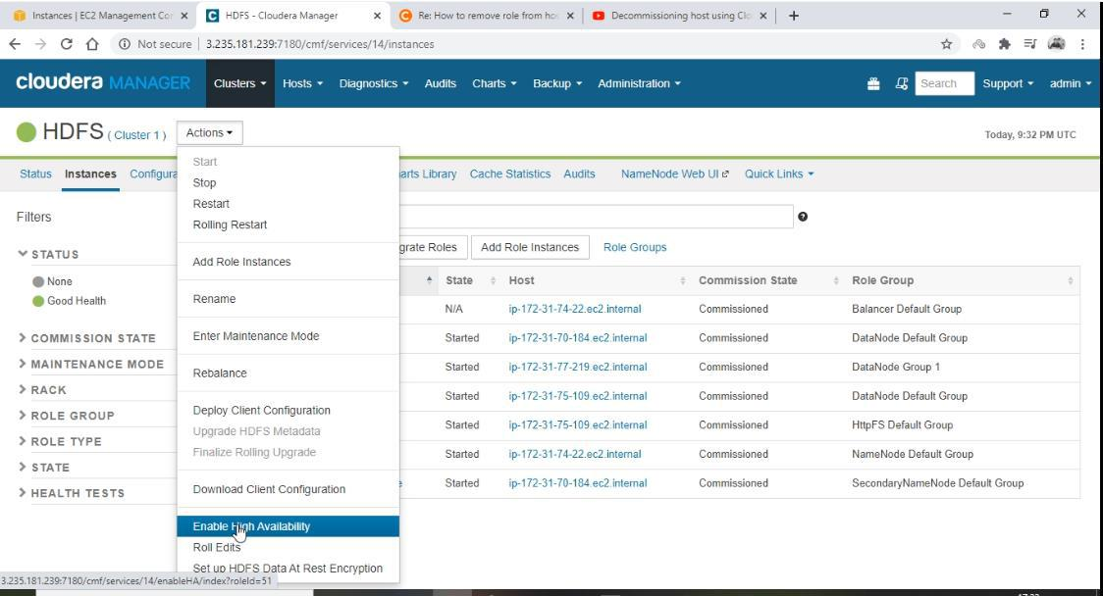

- Create a namespace and map to it for high availability which as a logical link for name node and secondary name node.
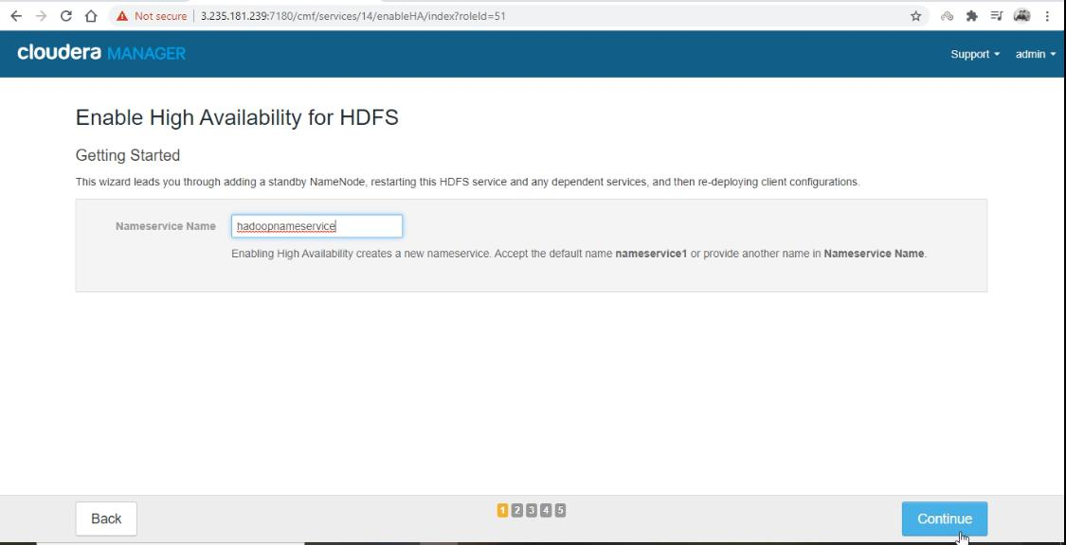

- Provide another host which you want to act as standby. Default name node host is selected, select 3 other hosts to act as journal nodes (odd number of hosts is recommended). Journal nodes are

Page 3

the ones which make active name node and standby name node in sync by reading and writing the edits and logs from active name node to stand by name node.
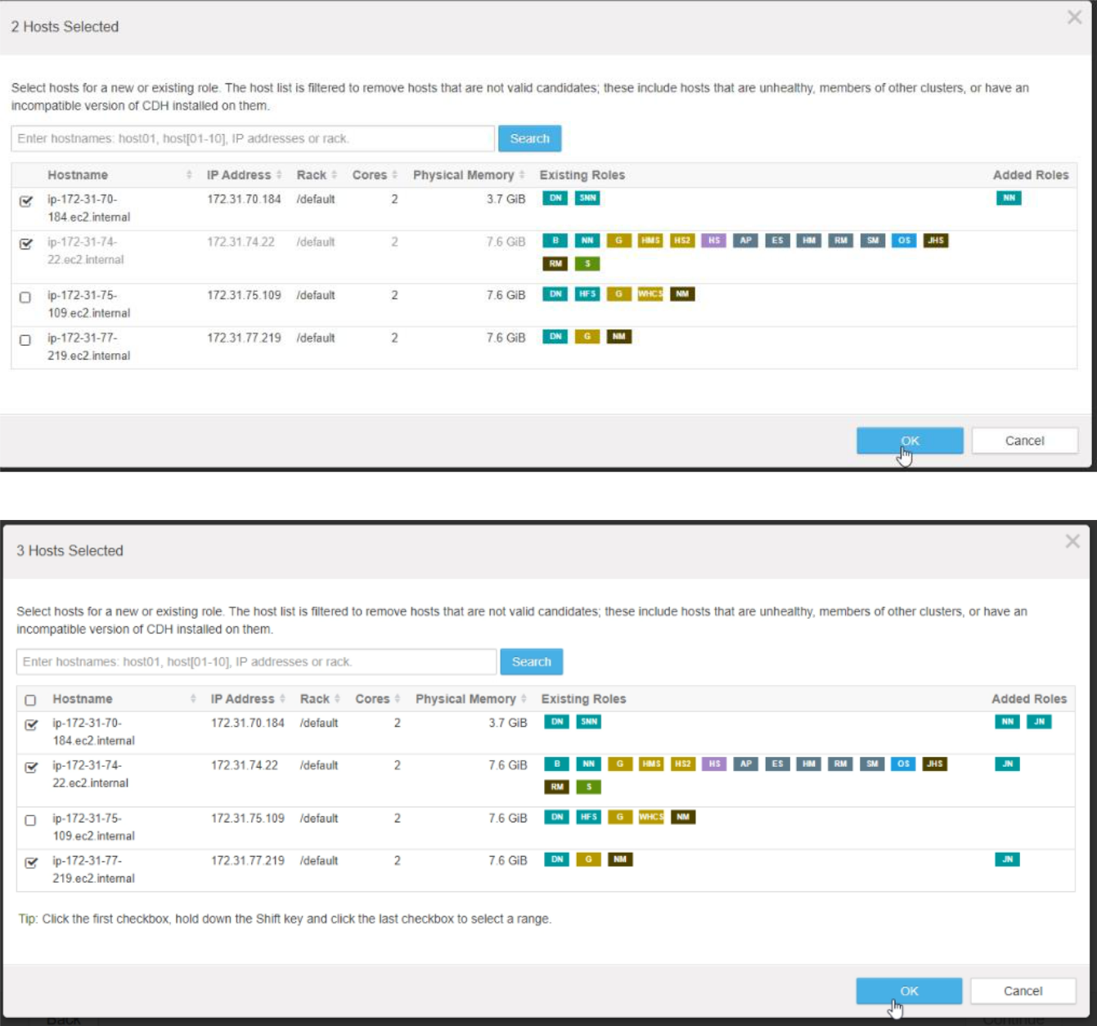

- Press continue once you selected hosts for journal nodes and standby name node.

- Provide the directory path of journal nodes on local file system where name node edits are written.

Page 4

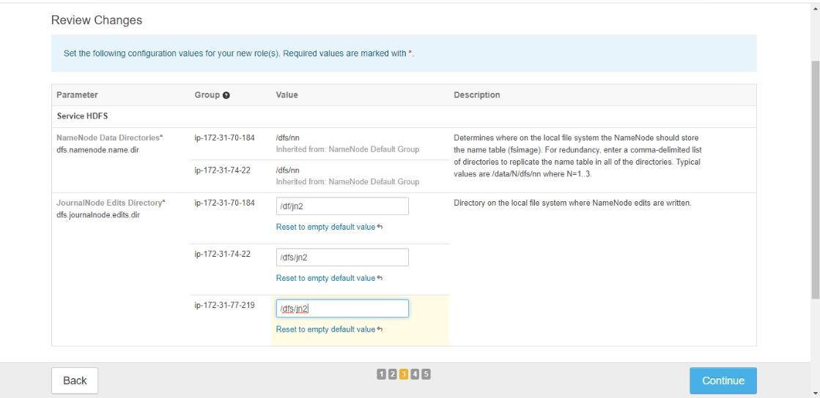

- Operations for high availability configuration takes place next as below:
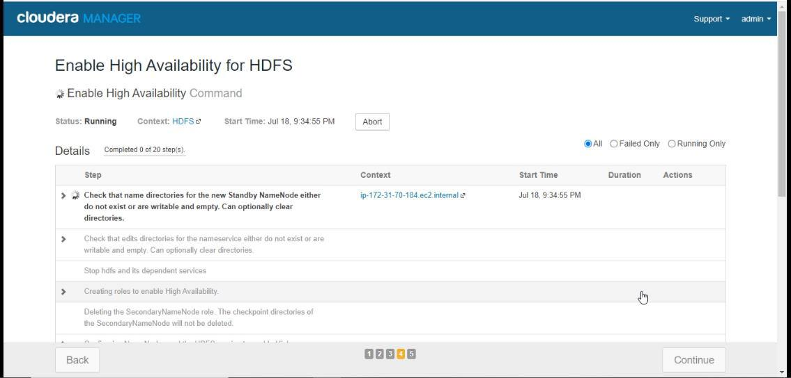

- Once you have all green ticks press continue.

Page 5

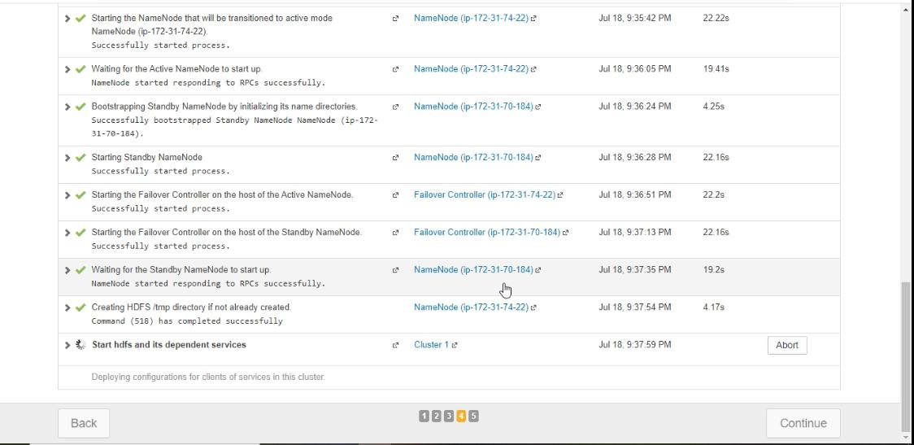

- HDFS High Availability is successfully set up press finish.
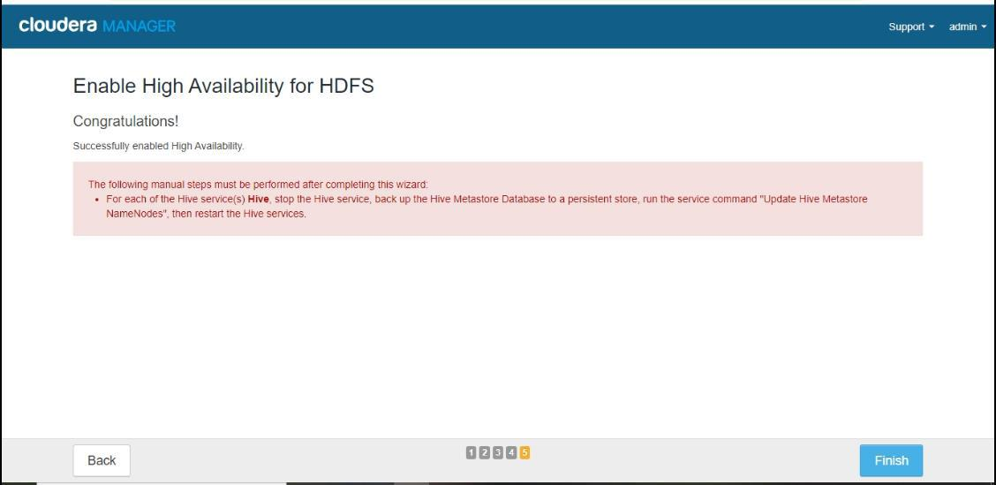

- To check High Availability.

- Home → HDFS -> Instances there you can see one host acting as name node and other as standby name node.

Page 6

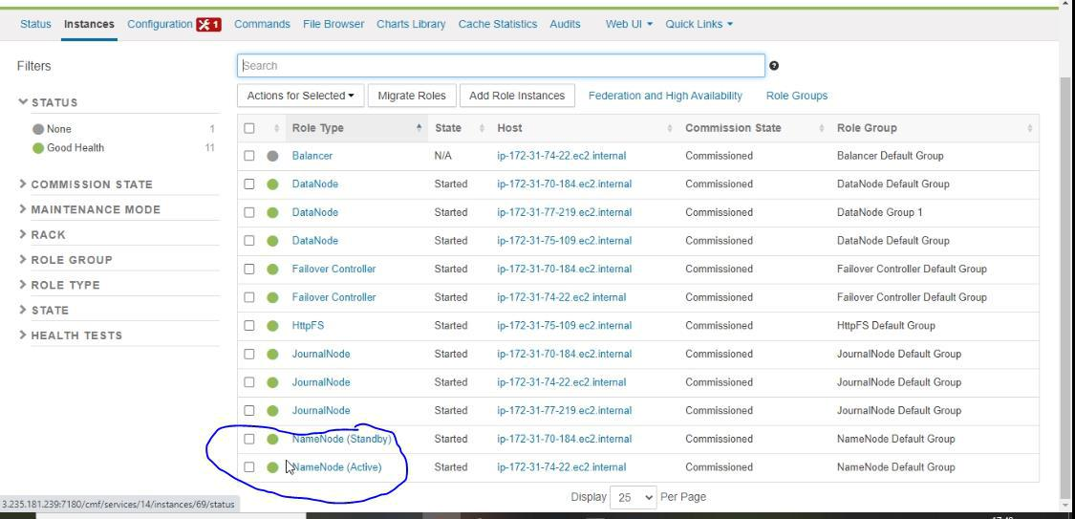

Testing High Availability.

- Select the Active Name node → Go to Actions for selected and select stop.
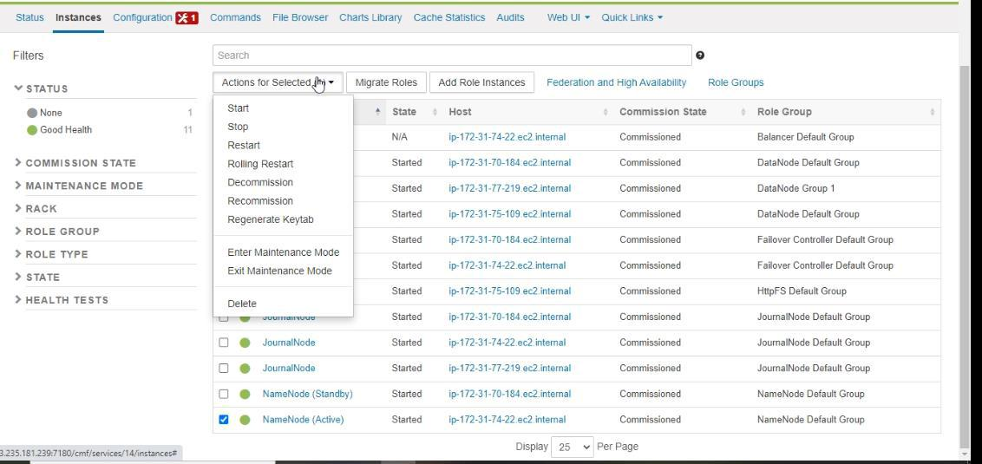

- Select stop.

Page 7
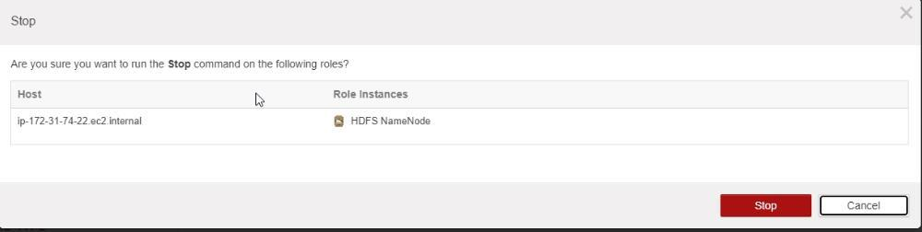

- Once operations are done. Press close.
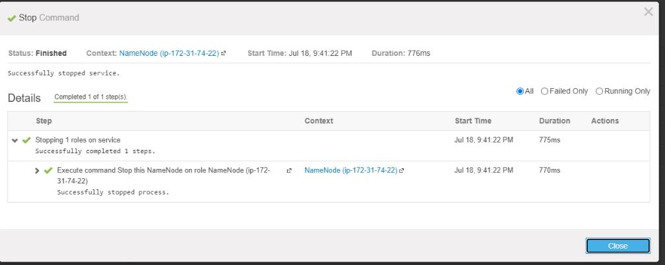

- Once Active name node has been stopped then the host acting as standby secondary name node become active.

Page 8

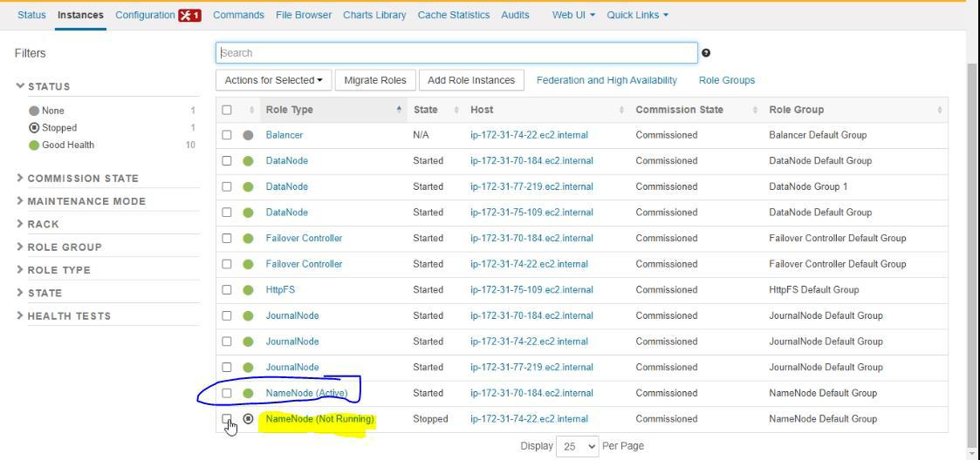

- Start the name node service (not running) to acts as stand by name node → Actions for selected → start

Page 9

